Department of Electrical engineering

final year project proposal guidelines



Compiled by

FYP Committee

January 2020

**GENERAL GUIDELINES**

* All project proposals submitted by students must be assessed for feasibility before the research commences.
* Students are advised to read and understand the given guidelines
* Students will also have to prepare a presentation for the project proposal according to the mentioned guidelines
* Students will present the same before the FYP committee

1. **Font**

* All text should be printed in a clear font e.g., Times New Roman;
* All text should be 12 point with the exception of headings (see below).

1. **Headings and Sub Headings**

* Headings should be in Title case, bold font (14-point).



**IoT Based Water Quality Monitering System**

**Project Proposal Submitted to**

**The Department of Electrical Engineering**

**Sukkur IBA**

Muhammad Faizan

Attiq ur Rehman

Supervisor Name

Dr. Safeer Laghari

Submission Date:

15-01-2020

Sukkur IBA January 2020

**Table of Contents here**

Contents

1. Project Overview: 4

2. Aims and Objectives of Project: 5

3. Literature Review: 6

4. Methodology for Implementation of Project: 6

5. Project Plan/Gantt Chart: 7

6. Milestones 7

7. Budget Description: 7

8. References: 8

# 1. Project Overview:

The world is moving towards technology rapidly and with the marvellous innovations the life has become more easier than before. But still in the 21st century, some developing countries like Pakistan are facing with the problem of water pollution. The messy and dirty water is still being used for drinking purpose without any monitoring and filtering system. This water pollution is one of the major causes for various types of water-borne diseases such as dengue, cholera and malaria etc. for human beings. 40% of deaths in worldwide are caused by water pollution. Besides the human being the water pollution is also dangerous for animals and agriculture. Therefore, for the socio-economic growth of the country the system is required that monitor the quality of water.

This problem for the developing countries is increasing with the industrialization and growing population. The traditional system to monitor the quality of water is not reliable because it does not provide the information about the parameters of water like pH, turbidity, conductivity, temperature, etc. continuously. Therefore, we need to develop the real time system to monitor the quality of water so that the necessary actions can be taken on the time to remain safe from unsuitable situation.

Hence, there is need of developing better methodologies to monitor the parameters of water in real time. Therefore in this project we present a design and development of a low cost system for real time monitoring of the water quality in IoT (internet of things).The system consist of several sensors is used to measuring physical and chemical parameters of the water. The parameters such as temperature, PH, turbidity, conductivity of the water can be measured.

The pH sensor (SKU: SEN0161/0169) measures the concentration of hydrogen ions. It shows the water is acidic or alkaline. Pure water has 7pH value, less than 7pH has acidic, more than 7pH has alkaline. The range of pH is 0-14 ph. For drinking purpose, it should be 6.5-8.5pH. Turbidity sensor (SKU: SEN0189) is a measure of the degree to which the water loses its transparency due to the presence of suspended particulates. The more total suspended solids in the water, the murkier it seems and the higher the turbidity. Conductivity Sensor (SKU: SEN 0244) is a measure of water’s capability to pass electrical flow. This ability is directly related to the concentration of ions in the water. The more ions that are present, the higher the conductivity of water. Temperature sensor (DS18B20) is used to measure the temperature of the water.

The microcontroller will obtain and process the data from the sensors and sent the data to the IoT cloud server (**Arduino IoT Cloud** / ThingsSpeak / things network) through LoRa WAN gateway. **Arduino IoT Cloud** / ThingsSpeak is an Internet of Things (IoT) platform that lets you collect and store sensor data in the cloud and develop IoT applications. These IoT platform provides apps that let you visualize, analyze and then act to data.

**LoRa WAN** is a protocol designed for creating large-scale public networks. The technology allows for sensors to talk to the internet without 3G/4G or Wi-Fi. It has the long range as compared to the Wi-Fi or GSM. It can send the data to 10s of kilometre. It is lower power consumption technology. But it can’t sent the big data like videos. The maximum data that can be sent is 50Kbps. Therefore it can be used to transfer the sensors data that does not change rapidly.

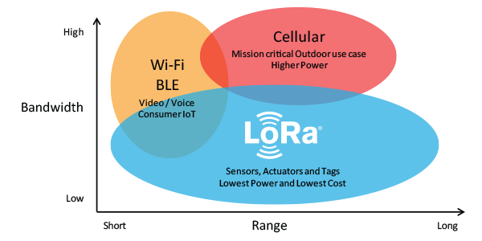

The Arduino MKR WAN 1310 board provides a practical and cost effective solution to add LoRa connectivity to projects requiring low power. This board can be connected to the [Arduino IoT Cloud](https://create.arduino.cc/getting-started/no-supported-os), your own LoRa network using the [Arduino LoRa PRO Gateway](https://store.arduino.cc/arduino-pro-gateway-lorar-connectivity).

**Flow diagram:**

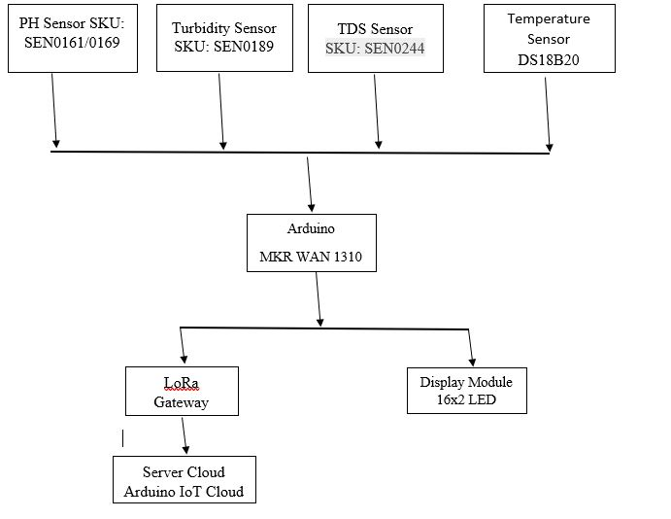

# 2. Aims and Objectives of Project:

* To monitor the real time parameters (pH value, turbidity etc.) of water. So, that the quality of water can be improved.
* To save the life of human being and animals monitoring the drinking water.
* Provide the reliable and low-cost system to real time monitor the water quality.
* Provide a system that can be accessed and monitor anywhere in the world by using the IoT.
* To utilize and implement the knowledge and skills that we have learn in undergraduate.

# 3. Literature Review:

This section provides a literature review of other water quality monitoring system.

Faheem Redwan entitled “An Exploratory Approach to Monitor the Quality of Supply-Water Through IoT Technology.” Published in 2019 International Conference on Automation, Computational and Technology Management (ICACTM). An IoT based water monitoring system is represented in this paper. In this project the microcontroller is powered by solar energy which is a sustainable approach as well. He measured different parameters of water like pH value, turbidity, arsenic level and salinity. Based on these parameters, he determined the quality of water. The measured parameters are sent to cloud server using Wi-Fi-module. IoT based platform help us to get a real time quality parameter at anywhere anyplace in the world. Thingspeak platform is used to examine, analyze the real time data.[4] Although it is sustainable approach to use solar energy but it is not efficient in cloudy seasons. We are unable to get quality parameters information in that condition. Other defect is to use wifi Module because we did not able to analyse and monitor the quality parameters at long distance because of short range of Wi-fi.

Vaishnavi V. Daigavane and Dr. M.A Gaikwad entitled “Water Quality Monitoring System Based on IOT”. This paper describes to ensure the safe supply of drinking water the quality should be monitored in real time for that purpose new approach IOT (Internet of Things) based water quality monitoring has been proposed. In this paper, they present the design of IoT based water quality monitoring system that monitor the quality of water in real time. This system consists some sensors which measure the water quality parameter such as pH, turbidity, temperature sensor and flow sensor. The measured values from the sensors are processed by microcontroller and these processed values are transmitted remotely to the core controller that was Arduino. Finally, sensor data can be viewed on internet using Wi-Fi system.[5] The proposed model is designed to get information from single unit of water source not from multiple sample of water resources.

Manoharan.S, Sathiyaraj.G, Thiruvenkadakrishnan.K, Vetriselvan.G.V, Praveenkishor entitled “

Water Quality Analyzer using IoT”. In this article, author offered a design to analyze the quality of water in real time using IOT at low cost. Author measured the physicameter like pH level, turbidity and conductivity. A centralized device is used to accept data from sensors. Arduino is used as data reader. Then the data is sent to cloud server using wi-fi system.[6] The proposed model used the limited numbers of sensors and is designed to check only the water quality parameters of rivers.

Fiona Regan, Antóin and Audrey [19] designed smart water quality monitoring system. In that system they made water quality smart sensors so the sensors send data wirelessly to the device which collects data from all the nodes. This data is given to the remote server through GPRS network and user can see data remotely. This system is highly scalable, faster and user friendly, but it is costly because of smart sensors. Furthermore, the size of sensors are not reliable for water tap.

# 4. Methodology for Implementation of Project:

1. First of all, we review the literature on IoT based the water quality monitoring system.
2. Study the microcontroller i.e input and output, analog and digital pins, memory etc.
3. Perform the small task and projects to have strong command on the microcontroller.
4. Study the sensors and components used in the projects.
5. Interface the components and sensors used in the project with the microcontroller.
6. Study the ‘ThingSpeak’ i.e. cloud server and the protocols used to transfer the data on the cloud.
7. Compare the obtained data with standard values of parameters of pure water.
8. Provide the display for user friendly.
9. Design the prototype.
10. Finalize the thesis of the project.

# 5. Project Plan/Gantt Chart:

|  |  |  |  |  |  |  |  |  |  |  |  |  |  |
| --- | --- | --- | --- | --- | --- | --- | --- | --- | --- | --- | --- | --- | --- |
| **Task No** | **Task Name** | **2020**    **2013-2014** | | | | | | | | | | | |
| **01** | **02** | **03** | **04** | **05** | **06** | **07** | **08** | **09** | **10** | **11** | **12** |
| **1** | Literature Review |  |  |  |  |  |  |  |  |  |  |  |  |
| **3** | Study and interface Sensors with microcontroller |  |  |  |  |  |  |  |  |  |  |  |  |
| **4** | Preparation of Schemes / Model |  |  |  |  |  |  |  |  |  |  |  |  |
| **5** | Implementation of Schemes/Model |  |  |  |  |  |  |  |  |  |  |  |  |
| **6** | Analysis & Simulation |  |  |  |  |  |  |  |  |  |  |  |  |
| **7** | Final Write-up &  Thesis Submission |  |  |  |  |  |  |  |  |  |  |  |  |

* *In the Gantt chart above the numbers from 1-12 represents months of the year.*

# 6. Milestones

**1st Quarter of the year:** Literature review

**2nd Quarter of the year:** Programming andSuccessful testing of the developed algorithm/technique.

**3rd Quarter of the year:** Results analysis and thesis write-up for final submission.

# 7. Budget Description:

|  |  |  |  |
| --- | --- | --- | --- |
|  | Items | Unit Cost (USD) | Total cost |
| 1 | Arduino MKR WAN 1310 – 2 units (<https://store.arduino.cc/usa/mkr-wan-1310>) | 38 |  |
| 2 | Turbidity sensor SKU : SEN0189 – 2 units  <https://www.digikey.com/products/en?keywords=SEN0189> | 10 |  |
| 3 | pH sensor with conversion board SKU:SEN0161/0169 – 2 units  <https://www.digikey.com/product-detail/en/dfrobot/SEN0161/SEN0161-ND/6579368> | 39 |  |
| 4 | Temperature sensor DS18B20 – 5 units  <https://www.digikey.com/product-detail/en/maxim-integrated/DS18B20/DS18B20-ND/420071> | 3.34 |  |
| 5 | Arduino compatible Total dissolved solids (TDS) sensor, – 2 units  <https://www.dfrobot.com/product-1662.html> | 9.90 |  |
| 6 | Arduino compatible 16x2 LCD display shield – 1 unit  <https://electropeak.com/1602-lcd-keypad-shield-for-arduino> | 9.90 |  |

# 8. References:

[1] An Exploratory Approach to Monitor the Quality of Supply-Water Through IoT Technology. 2019 International Conference on Automation, Computational and Technology Management (ICACTM) Amity University.

[2] Water Quality Monitoring System Based on IoT. Advances in Wireless and Mobile Communications. ISSN 0973-6972 Volume 10, Number 5 (2017), pp. 1107-1116 © Research India Publications.

[3] Water Quality Analyzer using IoT. International Journal of Innovative Technology and Exploring Engineering (IJITEE) ISSN: 2278-3075, Volume-8, Issue-8S, June 2019.

[4] IoT Based Real-time River Water Quality Monitoring System. The 16th International Conference on Mobile Systems and Pervasive Computing (MobiSPC) August 19-21, 2019, Halifax, Canada.

1. **Undertaking**

This report has been prepared on the basis of my own work where other published and unpublished source materials have been used, these have been acknowledged or referenced.

Signature of Students

Name of Students

Registration Numbers

1. **Supervisor’s Comments**

Take recommendation of your supervisor for your project work here.

Signature of Supervisor

Name of Supervisor

Designation of Supervisor

1. **FYP Committee Remarks**

*Do not write anything here. For official use only*

Name & Signature

Chairman/Vice Chairman